DATA SCIENCE MINOR PROJECT REPORT
DATA SCIENCE TOOLBOX : PYTHON PROGRAMMING
PROJECT REPORT
(Project Semester January-April 2025)

TITLE -: Goods and Services Tax (GST) Analysis Tool Python

Submitted by :-

Vikram Singh

Registration No:- 12311549

Programme and Section :- BTech CSE , K23GP Course Code: INT375

Under the Guidance of

Mrs. Aashima Mam , UID – 28968 , Assistant Professor LPU

Discipline of CSE/IT

Lovely School of Computer Science
Lovely Professional University, Phagwara

DECLARATION

I, Vikram Singh, student of BTech Computer Science And Engineering under CSE/IT Discipline at, Lovely Professional University, Punjab, hereby declare that all the information furnished in this project report is based on my own intensive work and is genuine.

Date: 12/4/2025
Registration No. 12313575

Signature

Vikram Singh

CERTIFICATE

This is to certify that Rajdeep bearing Registration no. 12311549 has completed INT 375 project titled, “Goods and Services Tax (GST) Analysis Tool Python” under my guidance and supervision. To the best of my knowledge, the present work is the result of his/her original development, effort and study.

Signature and Name of the Supervisor
Designation of the Supervisor
School of Computer Science Lovely Professional University Phagwara, Punjab.

Date:

ACKNOWLEDGEMENT

I would like to express my heartfelt gratitude to all those who have supported and guided me throughout the completion of this project titled “Goods and Services Tax (GST) Analysis Tool Python”. First and foremost, I would like to thank the Almighty for giving me the strength, knowledge, and perseverance to complete this work successfully.
I am deeply thankful to my respected faculty members and mentors at Lovely Professional University for their expert guidance, constant encouragement, and valuable feedback at every stage of this project. Their support helped me overcome challenges and develop a deeper understanding of the subject.
I also wish to acknowledge the Department of Computer Science and Engineering for providing me with the platform and resources to explore practical applications of programming, data analysis, and visualization. I extend special thanks to my classmates and friends for their continuous motivation, insightful discussions, and collaboration throughout this project. Their suggestions and teamwork helped enhance the quality of my work.
I would also like to express my gratitude to the creators and maintainers of the public datasets and Python libraries like Pandas, Matplotlib, Seaborn, which played a crucial role in making this project possible. Finally, I am immensely thankful to my family for their emotional support, patience, and encouragement during every step of this journey. Their love and belief in me kept me going through all obstacles. This project has not only helped me enhance my technical skills but also taught me the importance of analytical thinking and data-driven decision making.

INTRODUCTION
The Goods and Services Tax (GST) is one of the most significant economic reforms implemented in India. Introduced on 1st July 2017, GST replaced a complex web of indirect taxes with a unified system that aims to simplify taxation, enhance compliance, and promote ease of doing business. It is a destination-based tax, levied on the supply of goods and services, and comprises four major components—CGST (Central GST), SGST (State GST), IGST (Integrated GST), and Cess. These components reflect the division of tax revenues between the central and state governments and are crucial indicators of a region's economic activity and compliance levels.
This project focuses on the exploratory data analysis (EDA) of GST collections across India using Python. Leveraging publicly available datasets from the National Data & Analytics Platform (NDAP), the goal is to understand how GST collections vary across states, months, sectors, and tax components. By applying data science techniques and visualization tools, we aim to uncover trends, patterns, and insights that reflect the economic health and tax behavior of various regions in the country.
The analysis includes state-wise performance, monthly trends, component-wise contribution (CGST, SGST, IGST, Cess), and year-on-year growth, providing a comprehensive overview of how GST revenue evolves over time. Libraries such as pandas, matplotlib, and seaborn are used for data wrangling and visualization. The insights derived can help policymakers, researchers, and financial analysts make data-driven decisions.
In a world increasingly driven by data, this project demonstrates how Python-based data analysis can make complex fiscal data accessible and actionable, contributing to transparent governance and informed policy-making.

Source of Dataset
The dataset utilized in this project is sourced from the National Data & Analytics Platform (NDAP), an initiative by the NITI Aayog. NDAP provides high-quality, granular, and interoperable datasets from multiple government departments and ministries in India, aiming to promote data-driven decision-making and research. The specific dataset used pertains to Goods and Services Tax (GST) collections across various Indian states, sectors, and timelines. It contains publicly available government data detailing tax inflows from CGST, SGST, IGST, and Cess components. The dataset was accessed via:
🔗 https://ndap.niti.gov.in/catalogue
Key attributes include:
- State/UT Name: The region where GST is collected.
- Month & Year: Time period of collection.
- GST Type: CGST, SGST, IGST, or Cess.
- GST Collection (₹): Amount collected under each category.
- Sector (if applicable): E.g., Manufacturing, Services.
Before analysis, the dataset was cleaned and pre-processed to handle missing values, standardize date formats, and ensure consistency across numeric fields. This allowed for robust exploratory analysis and visualizations using Python libraries like pandas, matplotlib, and seaborn.
2. Exploratory Data Analysis (EDA) Process
EDA was essential to uncover key trends, detect patterns, and identify anomalies in GST collections across India. The following steps were followed:
- Data Loading and Cleaning • Libraries Used:
python
CopyEdit
import pandas as pd
import numpy as np
import matplotlib.pyplot as plt
import seaborn as sns
  - Steps Taken:
    - Loaded CSV/Excel data using pandas.read_csv().
    - Handled missing values and removed entries with null GST collection amounts.
    - Converted date-related columns to datetime format. o Ensured GST collection columns were numeric and free of formatting errors.
- Feature Engineering
To make the data more insightful:
  - Month-Year Extraction: From full date for trend plotting.
  - GST Category Aggregation: Grouped into CGST, SGST, IGST, and Cess.
  - State-wise Summarization: Total and average GST collected per state.
  - Quarter Mapping: For financial quarter-based analysis.
- Tools and Libraries Used
Library | Purpose
pandas | Data manipulation and grouping.
numpy | Numerical operations.
matplotlib | Plotting line charts and bar graphs.
seaborn | Advanced visualization: heatmaps, distribution.

Analysis on Dataset
- Monthly GST Collection Trends
Objective: Observe overall GST revenue over time.
  - Method Used: groupby(['Month-Year']).sum() + lineplot()
  - Insights:
    - GST revenue consistently increased post-2021 recovery.
    - Dips correspond with COVID-19 lockdowns or fiscal slowdowns.
- State-wise GST Contribution
Objective: Identify top contributing states.
  - Method Used: .groupby('State').sum() + .sort_values() • Top States: Maharashtra, Karnataka, Gujarat, Tamil Nadu.
  - Visualization: Horizontal bar chart of GST collections by state.
- Tax Component Analysis
Objective: Breakdown of CGST, SGST, IGST, and Cess.
  - Method Used: .pivot_table() + pie chart
  - Insight: SGST and CGST form the bulk of collections.
  - Visualization: Pie chart of overall tax contribution.
- Sector-Wise GST Patterns (if available)
Objective: Analyze how industries contribute to GST.
  - Method Used: .groupby('Sector').mean() + barplot()
  - Finding: Services and Manufacturing dominate GST inflows.
- Year-on-Year GST Growth
Objective: Evaluate fiscal performance year over year. • Method Used: .groupby('Year').sum() + barplot() • Result: Clear upward trend from 2019 to 2024.

4. Summary Dashboard & Key Insights Highlights:
- Top Contributors: Maharashtra and Karnataka lead in GST collection.
- Revenue Stability: Growth is stable with post-pandemic recovery.
- Component Share: SGST and CGST make up ~75% of GST revenue.
- Monthly Variation: End-of-quarter months often show spikes.
Visuals Used:
- Line charts (Month-wise trends)
- Pie charts (Tax type share)
- Heatmaps (State-wise GST variation)
- Bar plots (State, Year, Sector comparisons)

Conclusion
This project provided a deep dive into India’s GST collection patterns using open government data and Python analytics tools.
Key Takeaways:
- GST collections offer a vital indicator of economic activity.
- State and sector-level breakdowns help in policy evaluation.
- Data visualization made complex tax trends easier to interpret.
- The tool is valuable for policy analysts, researchers, and finance professionals aiming to evaluate tax health.
Impact:
- Empowers public stakeholders to understand GST distribution.
- Enables policy reforms through data-backed insights.
- Highlights economic contributions by state and sector.

Future Scope
- Forecasting GST Revenue o Use models like ARIMA or Facebook Prophet for future trend prediction.
- Correlation with Economic Indicators o Combine GST data with GDP, unemployment rates, inflation for macroeconomic analysis.
- Sector Deep Dive o Cluster sectors using K-Means for identifying high or low-performing industries.
- Interactive Dashboard o Deploy using Streamlit or Dash for real-time exploration.
- Anomaly Detection o Apply ML-based anomaly detection to catch data spikes or manipulation.

REFERENCES

- The pandas development team, pandas-dev/pandas: Pandas, Zenodo, 2020. [Online]. Available:
https://pandas.pydata.org
This Python library was used extensively for data manipulation, transformation, and cleaning in the project.
- J. D. Hunter, “Matplotlib: A 2D graphics environment,” Computing in Science & Engineering, vol. 9, no.
3, pp. 90–95, 2007. [Online]. Available: https://matplotlib.org
Matplotlib was used to create static, animated, and interactive visualizations, such as line plots, bar charts, and pie charts.
- M. Waskom, “Seaborn: Statistical data visualization,” Journal of Open Source Software, vol. 6, no. 60, p.
3021, 2021. [Online]. Available: https://seaborn.pydata.org
Seaborn provided advanced plotting functions and made it easier to draw attractive and informative statistical graphics.
- NumPy Developers, NumPy: Fundamental package for scientific computing with Python, [Online].
Available: https://numpy.org
NumPy was utilized for numerical operations, including computing averages, standard deviations, and handling arrays.
- Vellore Institute of Technology, Student Academic Records Dataset, Internal Data Source, 2025. This dataset contains anonymized CGPA records of VIT Vellore students across various academic years and branches. It served as the primary source for analysis.

LinkedIn Link : https://www.linkedin.com/posts/vikram-singh01_python-dataanalysis-gst-activity-
7316450925286420481-
vl8c?utm_source=share&utm_medium=member_desktop&rcm=ACoAAEUTEYQBnwA5kSf79efJSSO WpT0w4werQq0

GitHub Link : https://github.com/GEEKB0T/python-project

SnapShots of Project :
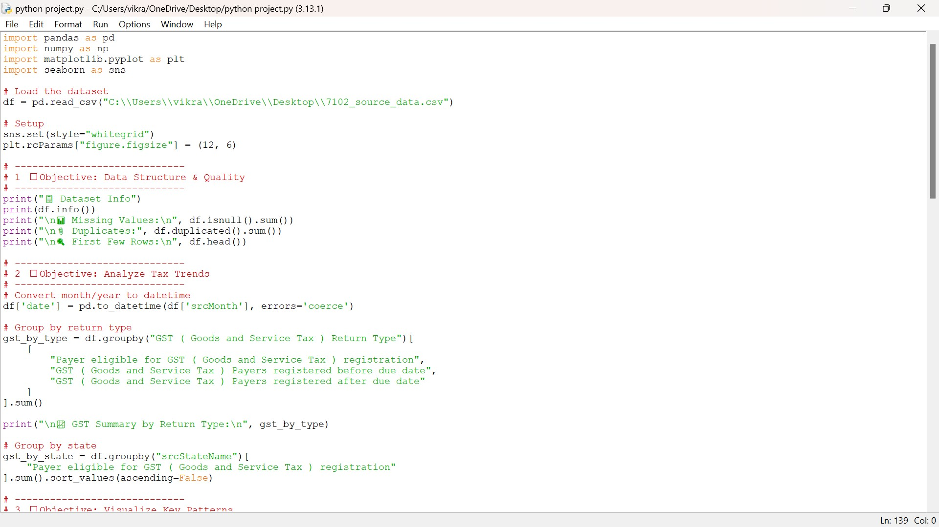
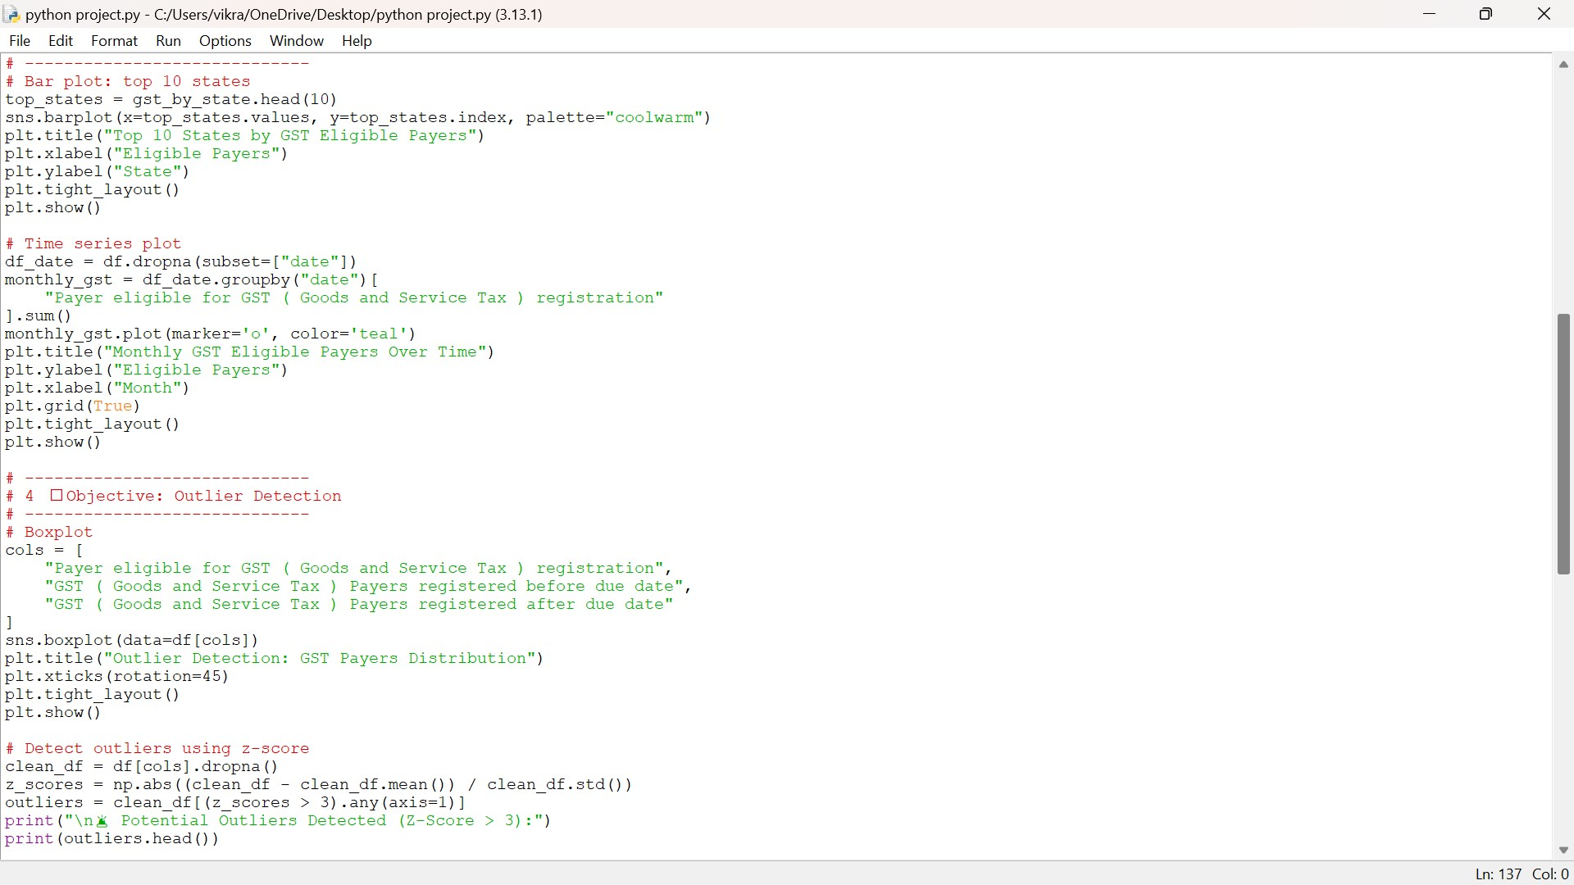

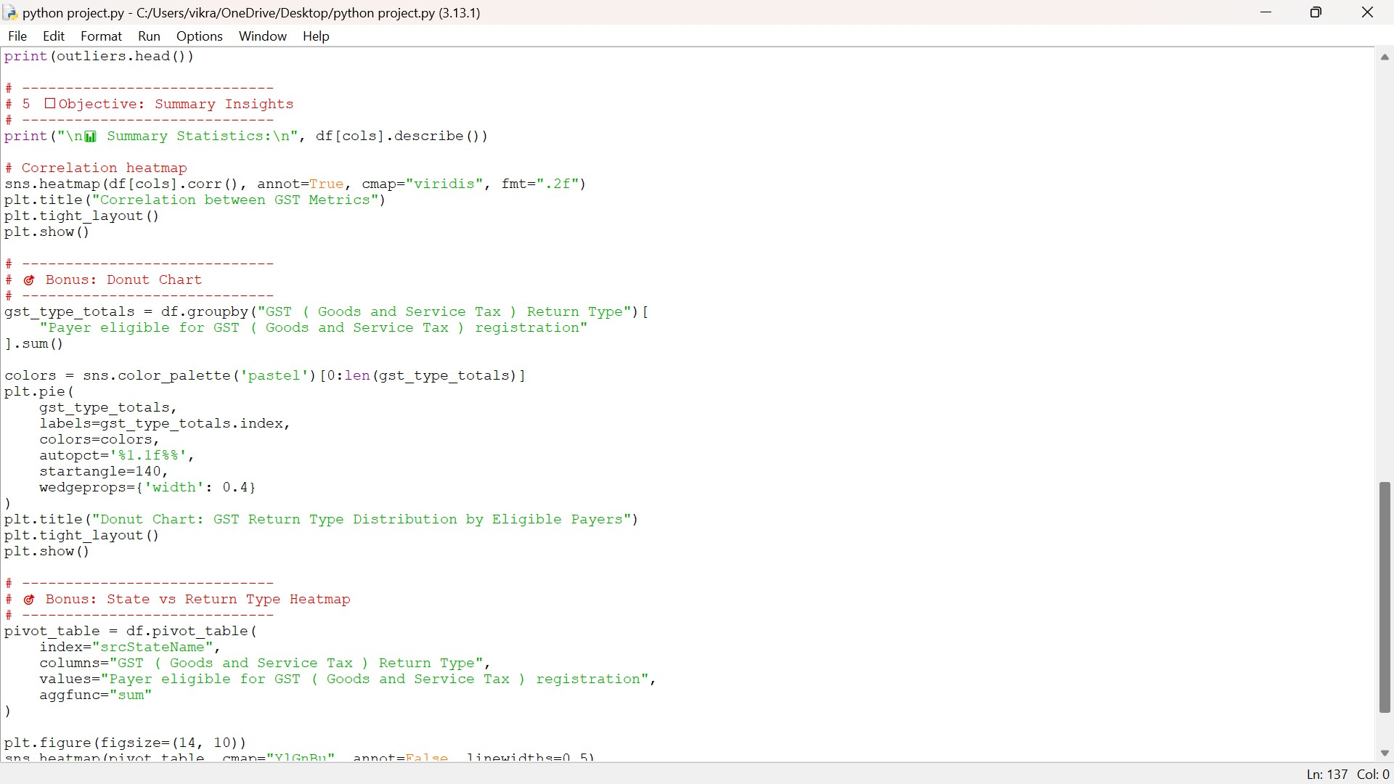

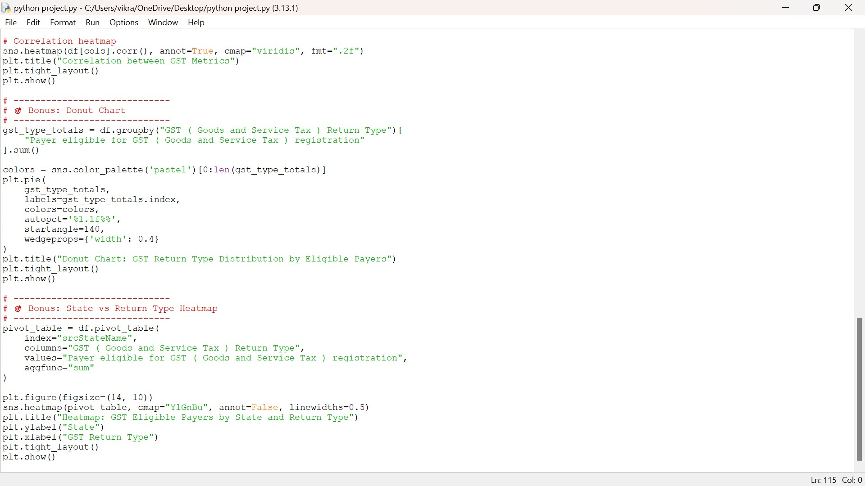

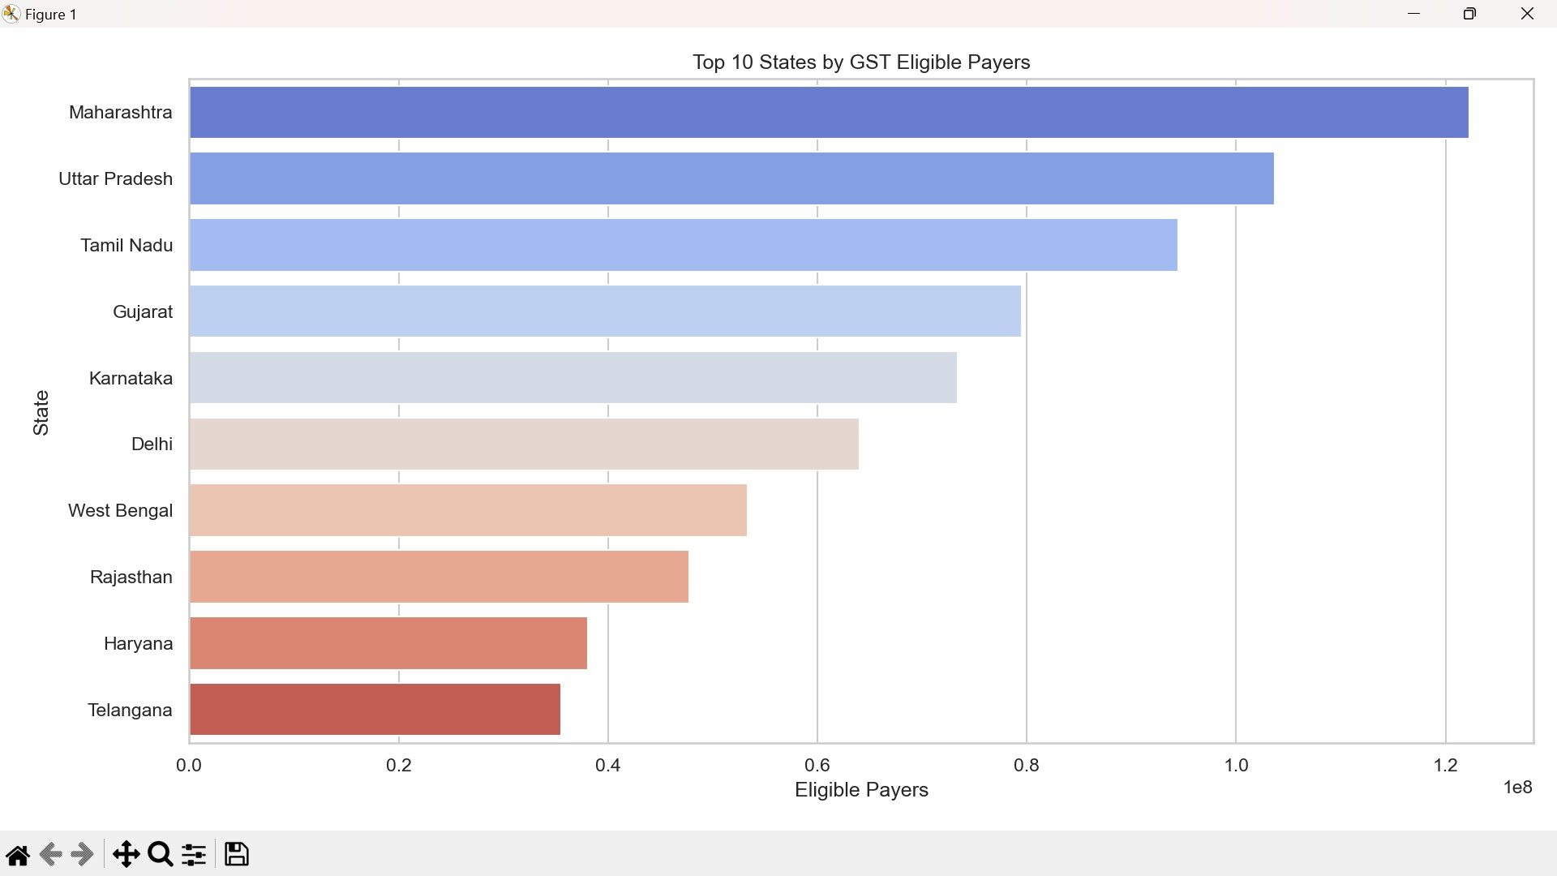
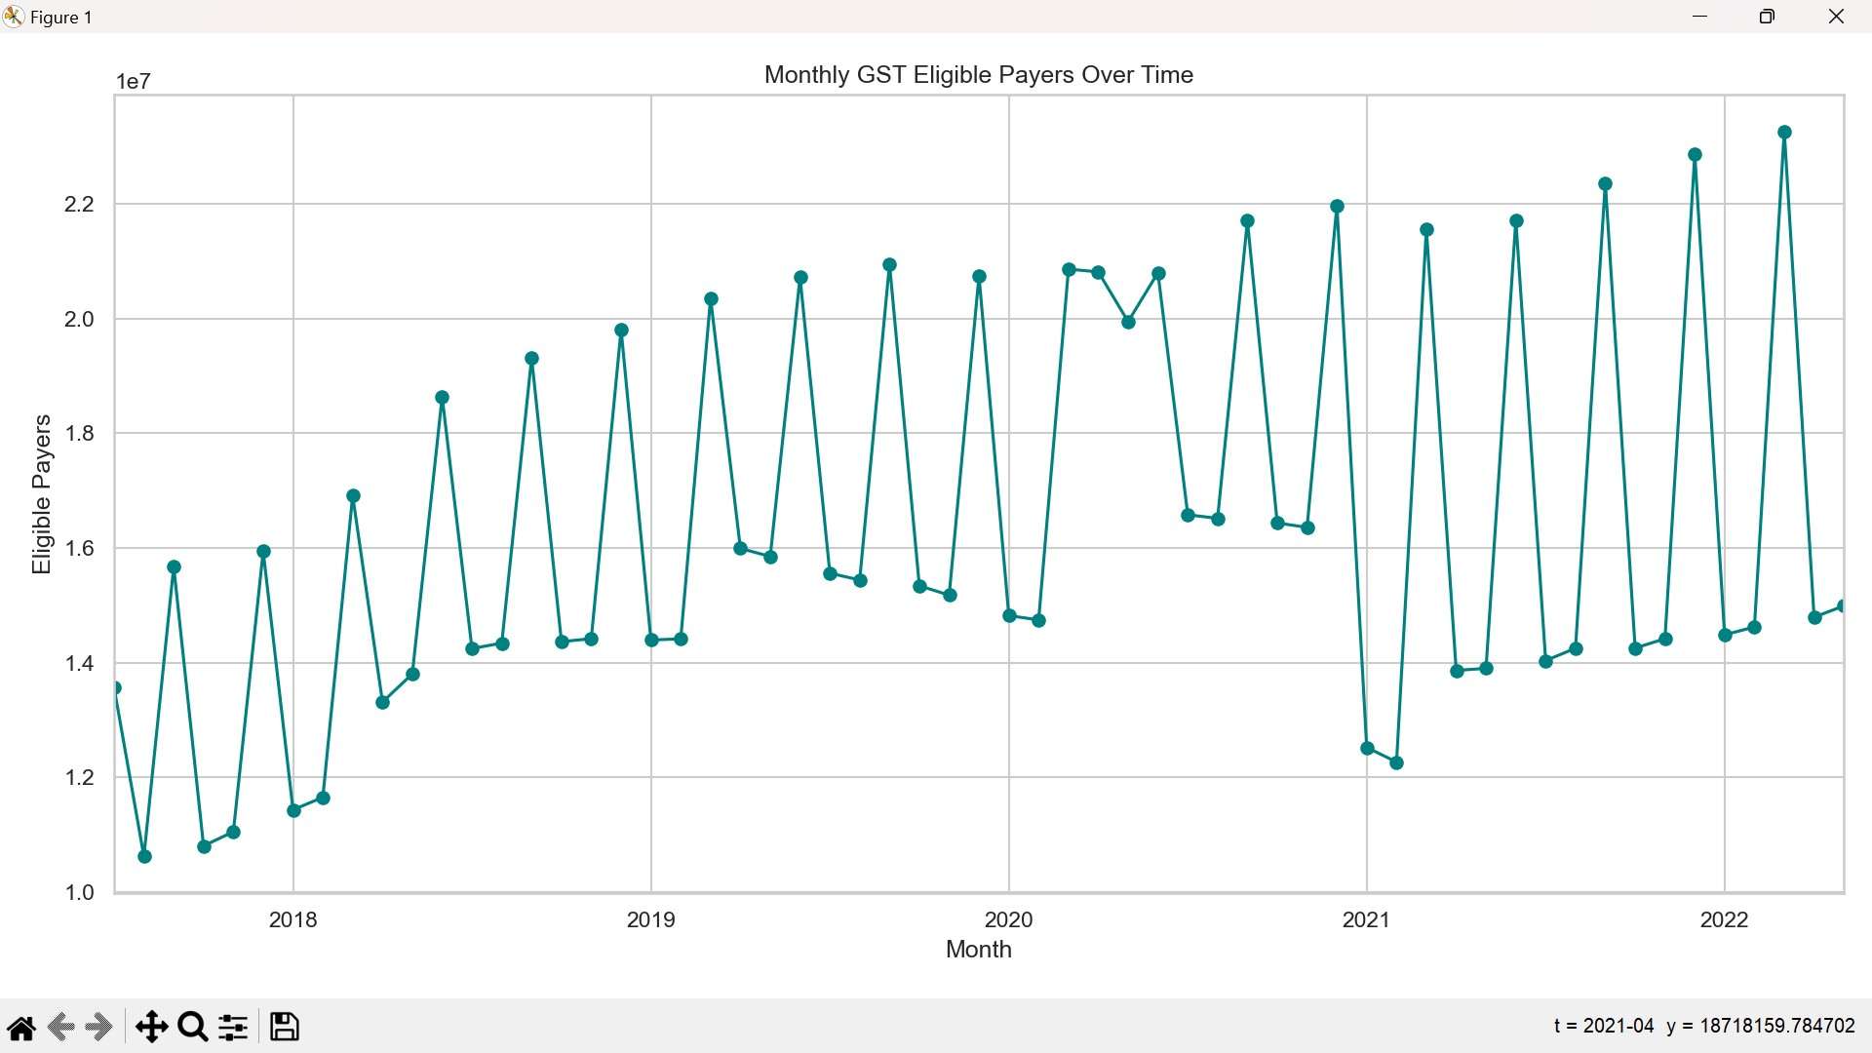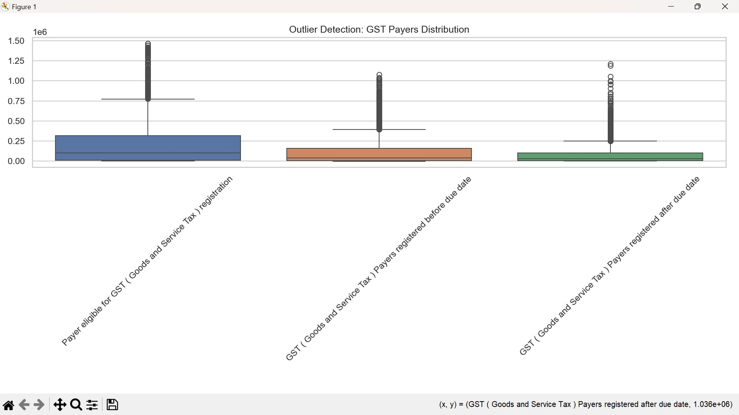
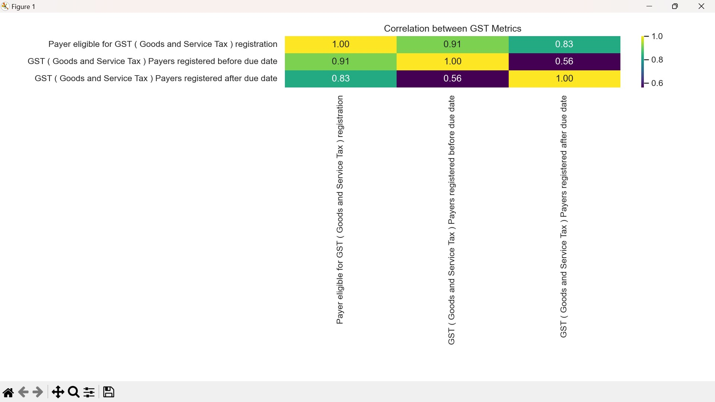
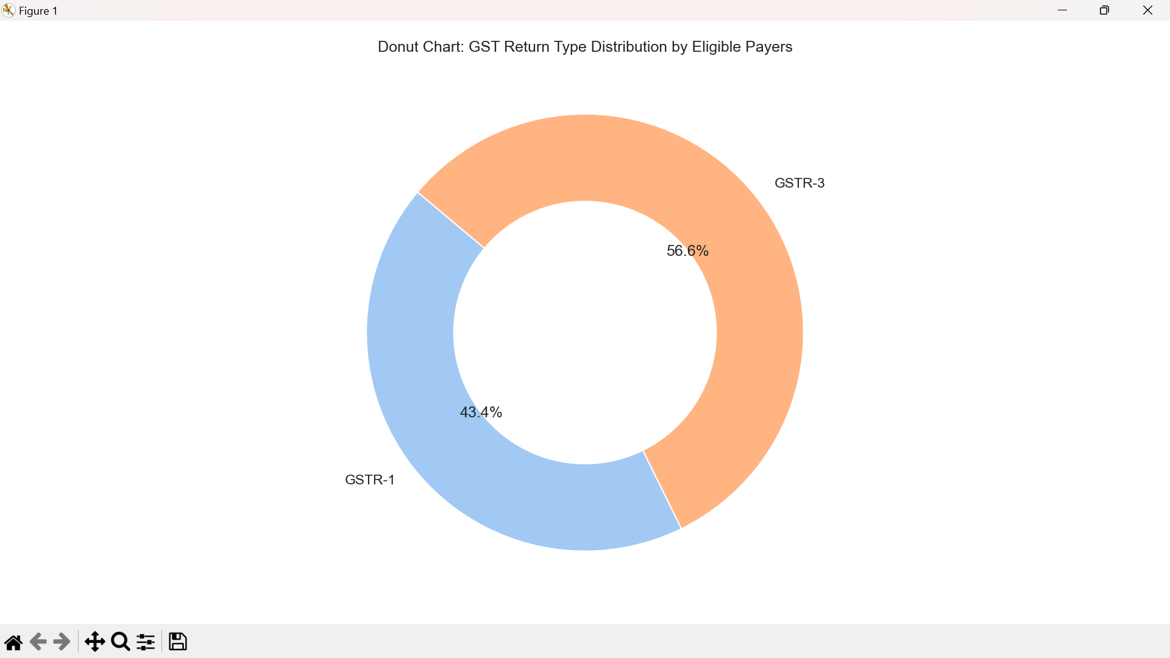

THANK YOU

